**Sprint 4 Review**

Title: Summarize Everything

Team: Summarize Everything

Mar. 8, 2022

**Actions to stop doing**

* Write unit tests in parallel to documentation/implementation. This will help with code coverage and reduce reworking non-compartmentalized portions of code

**Actions to start doing**

* Estimate group working progress using a more efficient and accurate way. This would make it more clear how much progress the team has made.
* Work in branches to squash and merge. This reduces the amount of merge conflicts and makes the commit history more aligned with tasks.

**Actions to keep doing**

* Peer review after commitment. This keeps team members accountable for what they say.
* Meet 3+ times a week for Sprint Stand-up. This reveals issues that might be present early on and encourages team members to make progress on each sprint.
* Commit and push frequently. This helps the team see that steady progress is being made and issues can be identified earlier on in the process.
* Keeping up with documentation. This avoids the issue of having to complete documentation after when it was relevant.

**Work completed/not completed**

* *Completed*
  + Extract main article data from general URLs sources
  + Created unit tests to run whenever code is pushed
  + Choose four best-performing models
* *Not Completed*
  + Automatically delete wrong phrasing article histories

**Work completion rate**

* # of completed User Stories: **4 of 4**
* Estimated work hours from sprint: **35 hr**
* # of days in sprint: **14**

**Completed burnup chart**

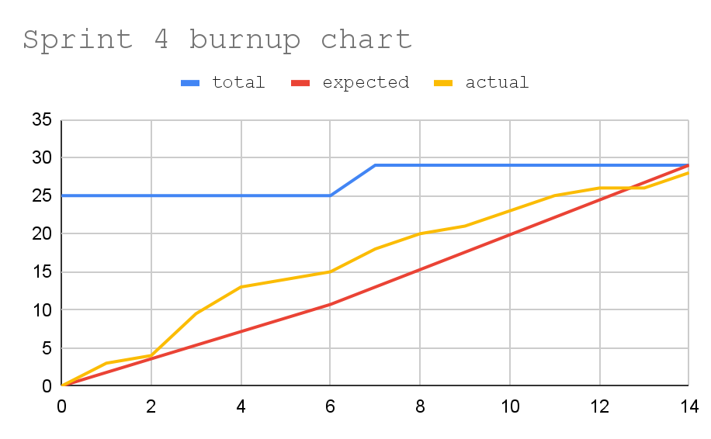

**Completed Scrum Board**

